RA8D1 SOM EVK

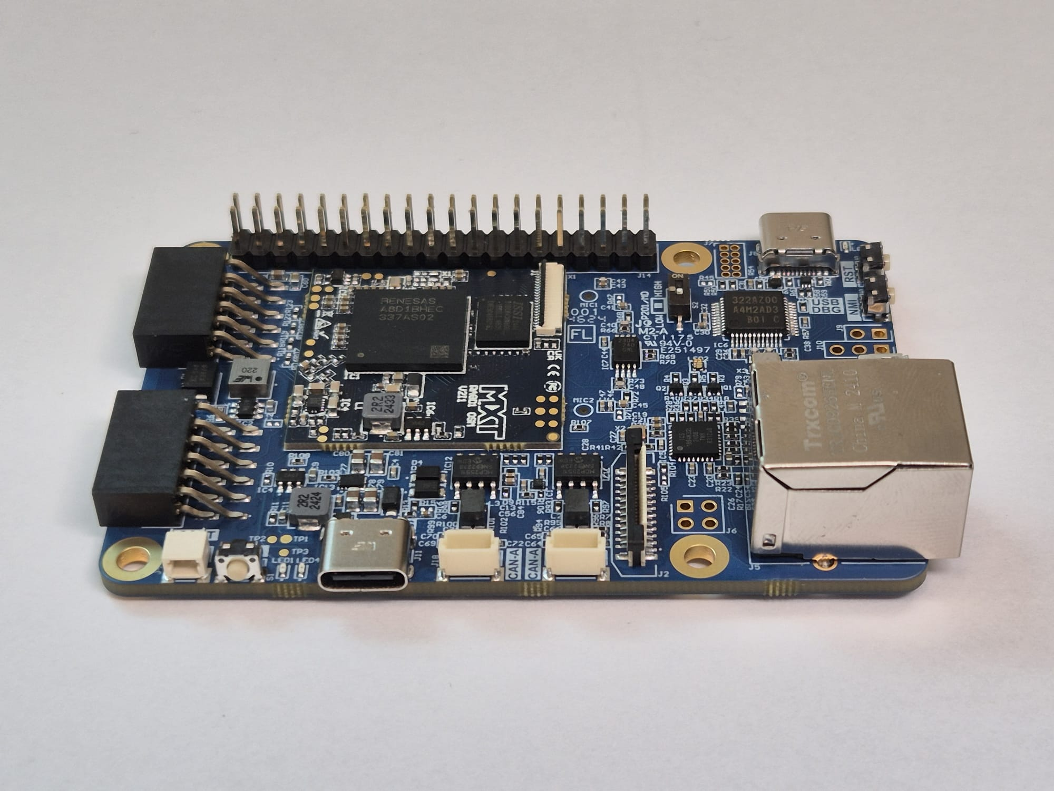User Guide

# Document Control

Document Version: 1.0

Document Date: 14/08/2024

Document Author: MXT Creation

Document Classification: Public

Document Distribution: Public

# Version History

|  |  |  |
| --- | --- | --- |
| Version | Date | Comment |
| 1.0 | 04/04/2025 | Naghi Dan Mihai |

# Contents

1. Document Control 2

2. Version History 2

3. Contents 3

4. Introduction 5

5. Overview 5

6. Features & Architecture 6

6.1. Processor and Architecture: 6

6.2. Memory: 6

6.3. Security: 7

6.4. Graphics & HMI: 7

6.5. Connectivity: 7

7. Included Items 7

8. Hardware Layout 8

9. Interfaces Summary 9

9.1. Power 9

9.2. Reset and Boot 9

9.3. Debugging 9

9.4. UART 9

9.5. USB 9

9.6. Ethernet 9

9.7. CAN 9

9.8. SDIO (SD Card) 9

9.9. SPI 10

9.10. I2C 10

9.11. I2S (Audio) 10

9.12. Microphones 10

9.13. Display Control 10

9.14. Camera Interface (CSI) 10

9.15. Expansion Connectors 10

9.16. LEDs and Indicators 10

10. Connector Interfaces 13

11. Debugging Interfaces 20

12. Power Consumption Measurements 22

13. Software Requirements and Tools 22

14. Firmware Flashing 23

15. Legal, Safety & Warranty Notices 23

16. Reference Documents 23

# Introduction

The RA8D1 SOM EVK is a compact, high-performance embedded computing platform developed around the Renesas RA8D1 microcontroller. It is designed for developers and engineers seeking a balance of performance, security, and rich interface support. This guide outlines the hardware features, setup, and operational overview of the RA8D1 SOM EVK, enabling quick and efficient development of embedded systems.

# Overview

The RA8D1 SOM + Carrier board features the Renesas RA8D1 microcontroller, built with a 480 MHz Arm Cortex-M85 core that supports the latest Arm Helium technology for DSP and ML workloads. It includes up to 2MB dual-bank code flash, 1MB SRAM, advanced graphics controllers (GLCDC and DRW), secure elements, and a variety of digital and analog interfaces.

Key Highlights:

* High-speed processing with Cortex-M85 + Helium
* Advanced HMI with MIPI-DSI, 2D drawing engine
* Secure boot and TrustZone for embedded security
* Battery-backed RTC and power-saving modes
* 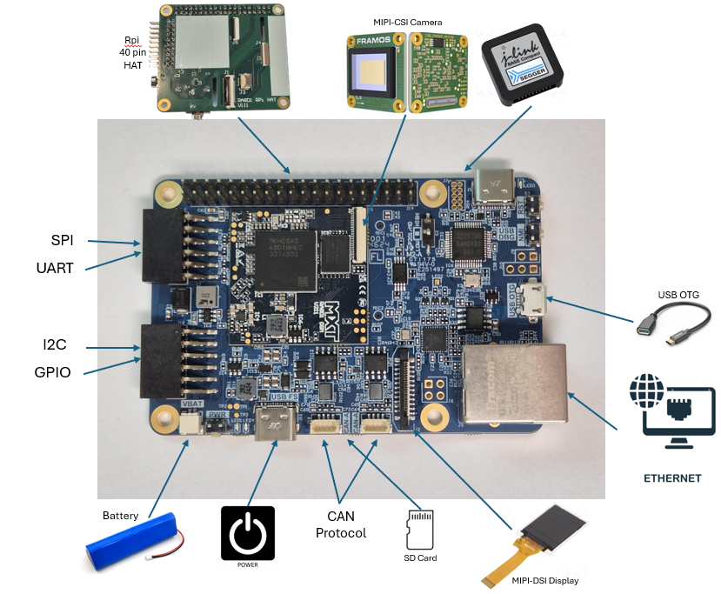USB HS/FS, Ethernet, CANFD, SDHI, SPI, I2C

# Features & Architecture

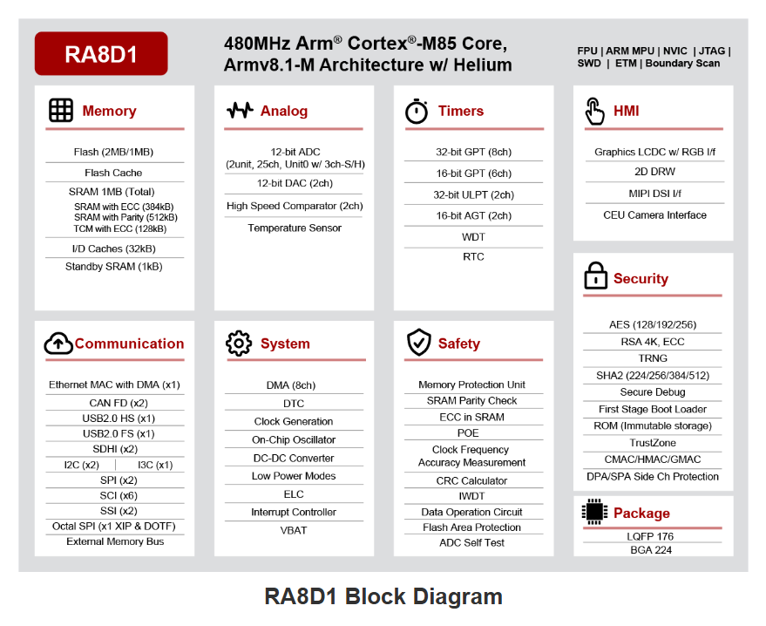

## Processor and Architecture:

* 32-bit Arm Cortex-M85 core (Armv8.1-M)
* Up to 480 MHz operation with FPU and Helium vector extension
* Memory Protection Unit (MPU) for secure applications

## Memory:

* 2MB dual-bank code flash for OTA and fail-safe updates
* 12KB Data flash
* 1MB SRAM (128KB ECC + 896KB parity checked)
* ROM with First Stage Bootloader (FSBL)

## Security:

* Renesas Secure IP: AES, RSA, ECC, Hash, unique ID
* TrustZone-M for secure/non-secure code isolation
* Secure boot, decryption on-the-fly, anti-rollback protection

## Graphics & HMI:

* MIPI-DSI for modern displays
* GLCDC: Graphics LCD controller
* DRW: 2D Drawing Engine

## Connectivity:

* USB 2.0 HS (Host/Device), USB FS
* Ethernet MAC/DMA Controller
* CANFD x2, I3C, I2C, SPI, UART
* SD/MMC via SDHI
* Octal SPI (OSPI)

# Included Items

* 1x RA8D1 SOM EVK
* Documentation Quick Start (digital)

# Hardware Layout

The SOM is soldered onto the carrier board, which includes power management, interface connectors, debug ports, and headers.

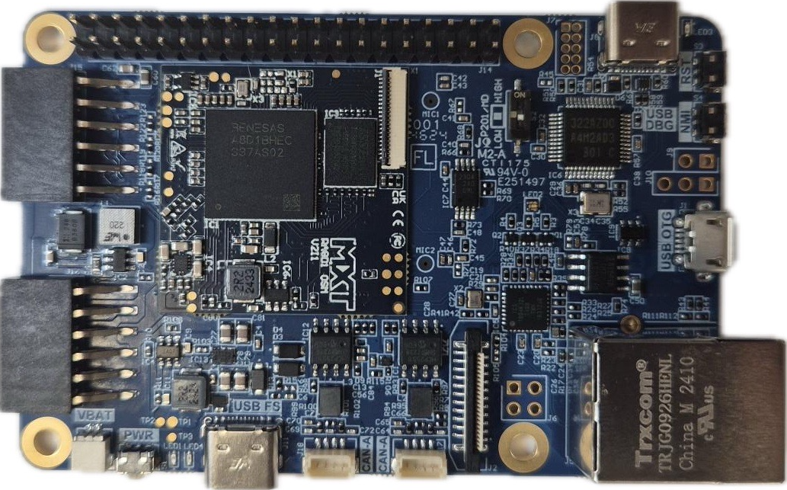

Figure - TOP Layer Hardware Layout

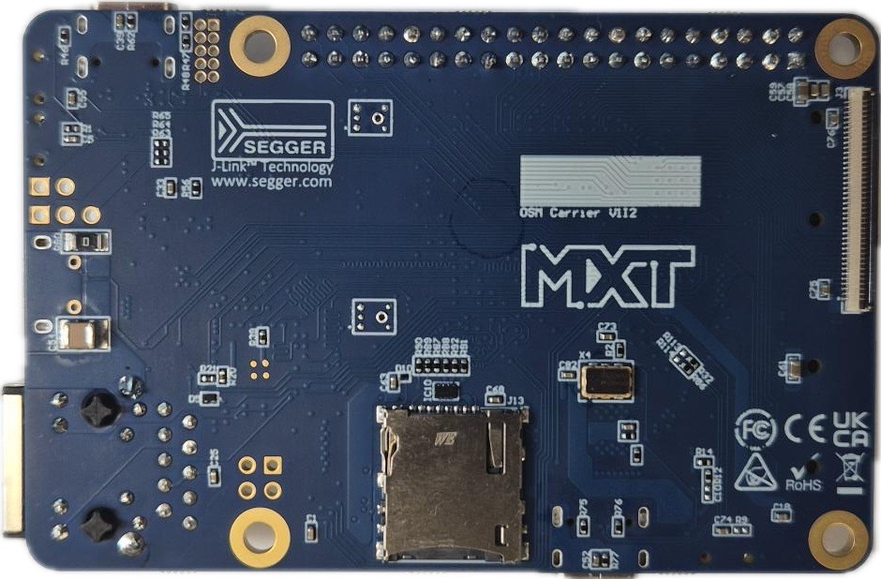

Figure - Bottom Layer Hardware Layout

# Interfaces Summary

## Power

* VCC_IN_5V: Multiple inputs for 5V – USB-C Debugger Interface, USB-FS or USB OTG
* VBAT: Backup power for RTC

## Reset and Boot

* SYS_RST: External reset input
* BOOT_SEL0: Boot mode selection

## Debugging

* J-Link OB debugger
* 10 pins JTAG Connector

## UART

* UART A, B (TX/RX/RTS/CTS lines) mapped to PMODs
* Dedicated UART Console interface

## USB

* Two USB interfaces (USB_A and USB_B)
* Supports Host/Device, OTG detection

## Ethernet

* RMII for Ethernet A

## CAN

* Dual CANFD support on CAN_A_TX/RX, CAN_B_TX/RX

## SDIO (SD Card)

* One SDIO Connector for micro SD Card

## SPI

* One SPI interface mapped to PMOD

## I2C

* Two I2C interfaces, I2C_A, I2C_B, mapped to PMODs

## I2S (Audio)

* I2S interface mapped to Rpi 40-pin Header

## Microphones

* Two Microphones, MIC1 and MIC2

## Display Control

* GLCD and RGB support through 40-Pin connector for 24-bit RGB panels on the back
* MIPI DSI with 4 data lanes and clock differential pairs

## Camera Interface (CSI)

* 4-lane MIPI CSI interface

## Expansion Connectors

* Raspberry Pi 40-pin header
* MikroE Click header options
* PMOD GPIO, SPI, I2C headers

## LEDs and Indicators

* Multiple LEDs and indicators
* RGB user LED
* Possibly software controllable via GPIO

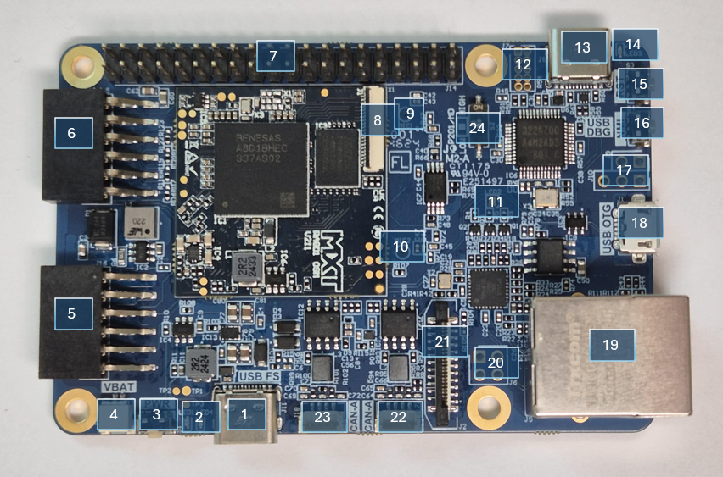

Figure - TOP Layer Interface Layout

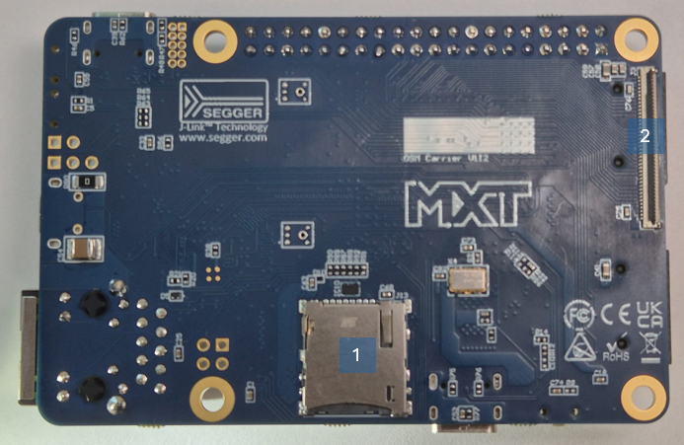

Figure - Bottom Layer Interface Layout

Table TOP Layer Component Desciption

|  |  |  |
| --- | --- | --- |
| # | Reference | Component Description |
| 1 | J11 | USB-C 5V Power input |
| 2 | LED1, LED4 | Power LEDs |
| 3 | S1 | Power Button |
| 4 | J4 | VBattery |
| 5 | J16 | PMod Type 6A |
| 6 | J15 | PMod Type 3A |
| 7 | J14 | 40-pin Expansion Header |
| 8 | J1 | MIPI CSI Camera Connector |
| 9 | MIC1 | Microphone Input 1 |
| 10 | MIC2 | Microphone Input 2 |
| 11 | LED2 | RGB LED |
| 12 | J7 | JTAG Connector |
| 13 | J8 | USB Debug Connector |
| 14 | LED3 | Debug LED |
| 15 | S3 | Reset Button |
| 16 | S4 | NMI Button |
| 17 | J9 J10 | J-Link OB Re-Programing |
| 18 | J1 | OTG USB Connector |
| 19 | J5 | Gigabit Ethernet Connector |
| 20 | J6 | TAP Connectors for Ethernet |
| 21 | J2 | MIPI DSI Display Connector |
| 22 | J17 | CAN_A Connector |
| 23 | J18 | CAN_B Connector |
| 24 | P201/MD | BOOT Mode Selection |

Table Bottom Layer Component Description

|  |  |  |
| --- | --- | --- |
| # | Reference | Component Description |
| 1 | J13 | Micro SD Card Slot |
| 2 | J3 | 40-Pin connector for 24-bit RGB panels |

# Connector Interfaces

* JTAG/SWD for debug
* USB Micro-B or Type-C
* RJ45 Gigabit Ethernet connector
* CAN connectors
* MIPI CSI Camera Connector
* MIPI DSI Display Connector
* PMOD TYPE 3A (12 pin header)
* PMOD TYPE 6A (12 pin header)
* 40-pin expansion header
* 40-Pin connector for 24-bit RGB panels

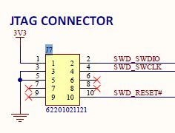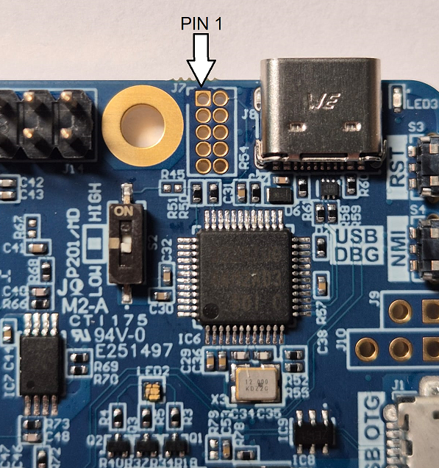

Figure - JTAG Connector Layout + Schematic

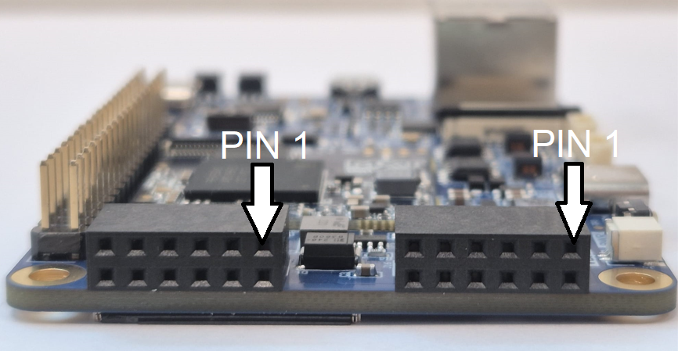

Figure - PMOD Layout

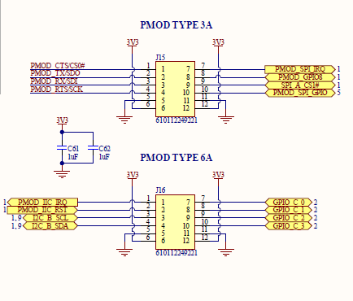

Figure - PMODs Schematic

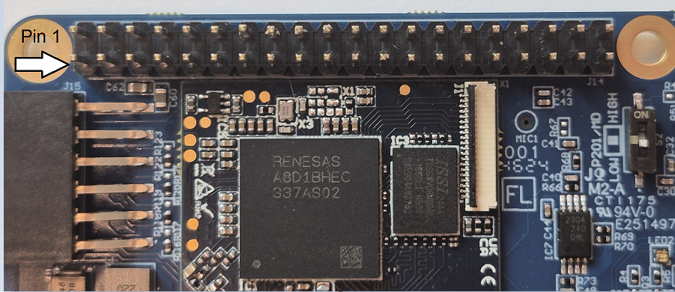

Figure - RPi 40 Pin Layout

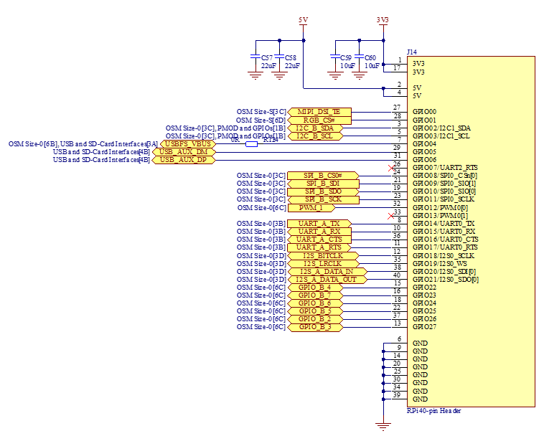

Figure - Rpi 40 Pin Schematic

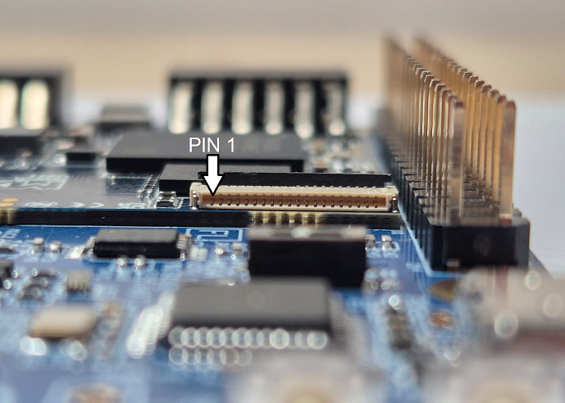

Figure - MIPI CSI Camera Layout

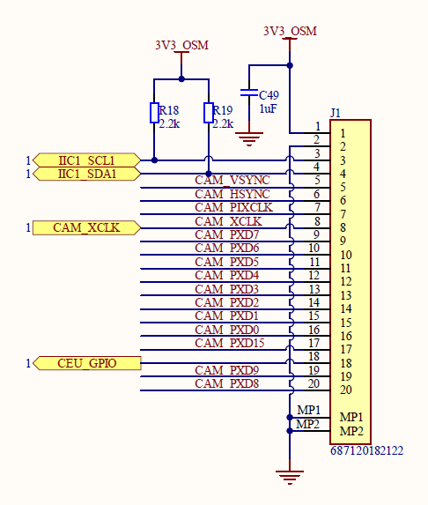

Figure - MIPI CSI Camera Schematic

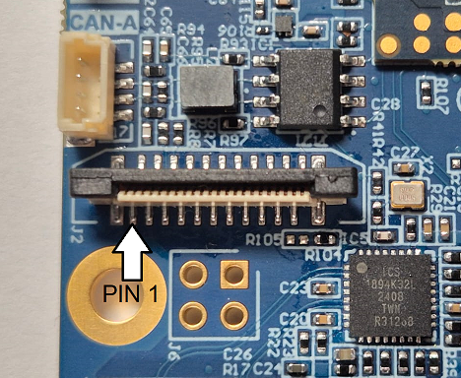

Figure - MIPI DSI Display Layout

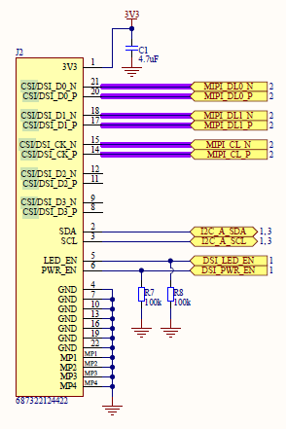

Figure - MIPI DSI Display Schematic

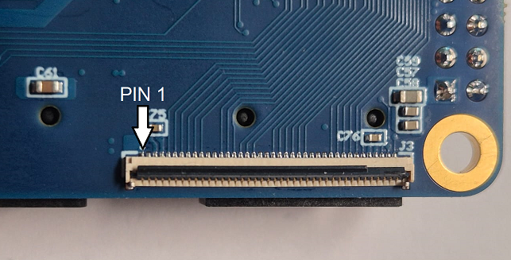

Figure - 40 Pin Display Connector Layout

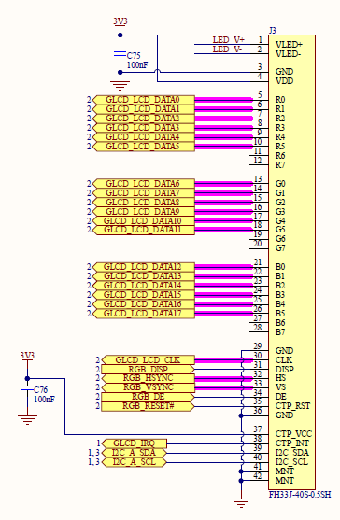

Figure - 40 Pin Display Connector Schematic

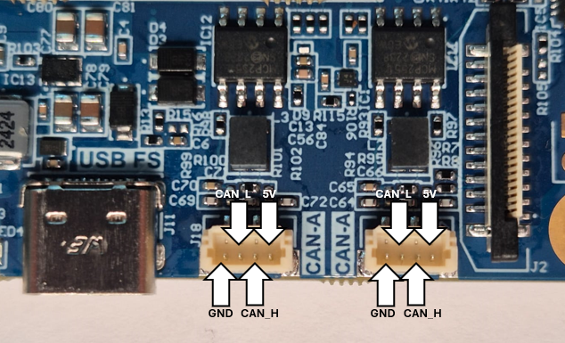

Figure - CAN_A CAN_B Connector Layout

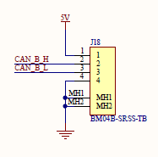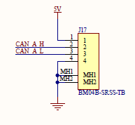

Figure - CAN_A CAN_B Connector Schematic

# Debugging Interfaces

The board supports SWD/JTAG debugging through a dedicated 10-pin header.

SWD/JTAG 10-Pin Debug Connector (J6):

* Debug Interface Voltage: 3.3V
* Recommended Tools: SEGGER J-Link, e2-Studio

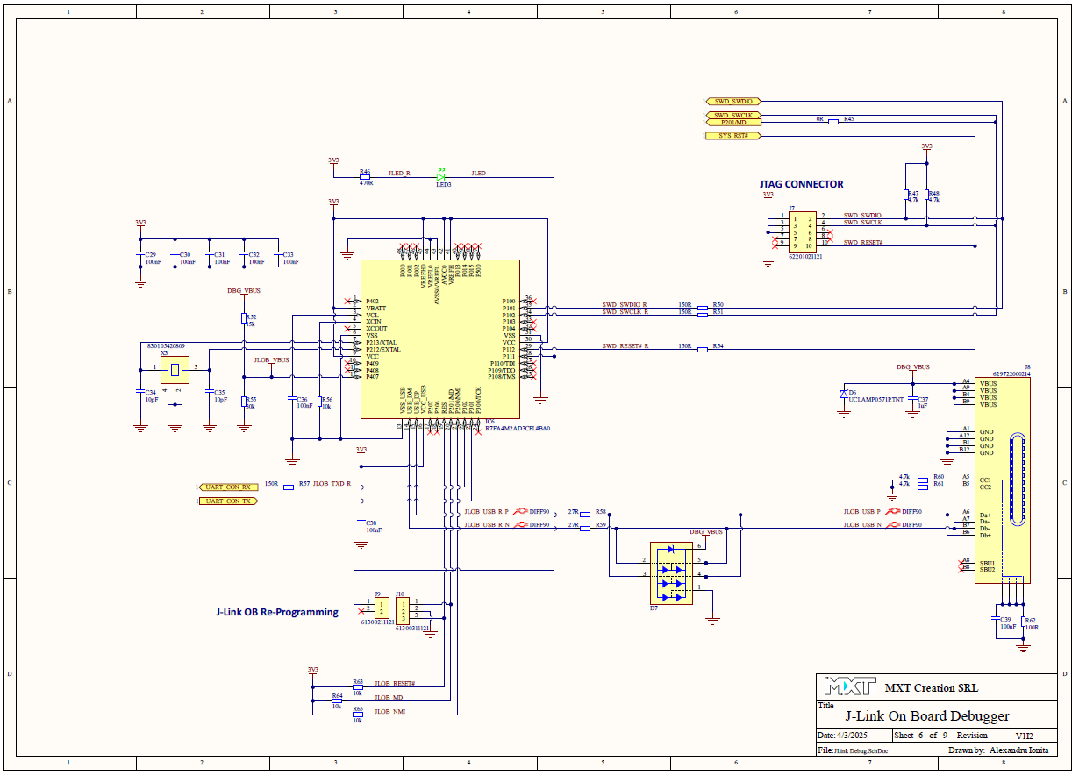

Figure - Debugging Interface Schematic

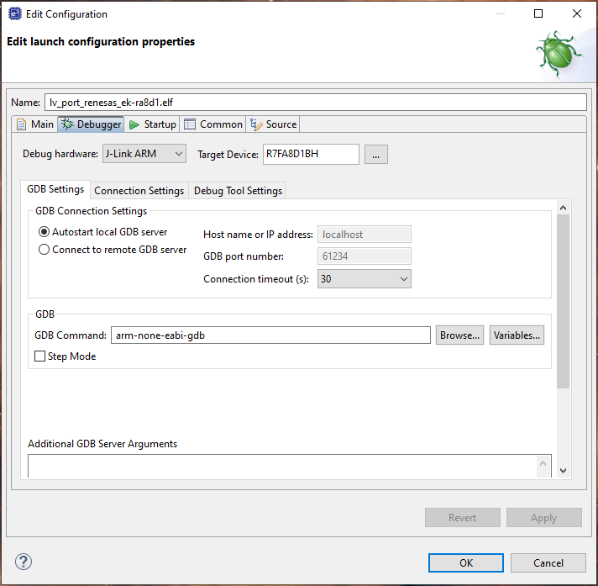

Figure - e2 Studio Configuration

# Power Consumption Measurements

An inexpensive current-measurement USB dongle is recommended during development, in-line with the USB power connection to monitor 5V input current draw. The USB dongle meter shown here accommodate type-C and type-A cable connections and is available online for around $20 [Tester-Eversame-Voltmeter-Ammeter-Braided](https://www.amazon.com/Tester-Eversame-Voltmeter-Ammeter-Braided/dp/B07MGQZHGM%20)



# Software Requirements and Tools

This section describes the development environment and tools typically used with the RA8D1 SOM EVK.

* IDE: Renesas e2 studio (latest version recommended)
* FSP: Flexible Software Package with RA8D1 support
* Serial Terminal: e.g., Tera Term or RealTerm
* Flashing Tool: SEGGER J-Link, Renesas Flash Programmer

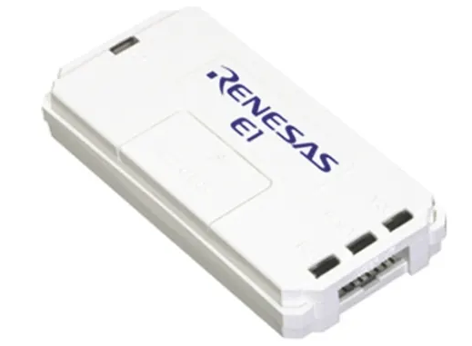 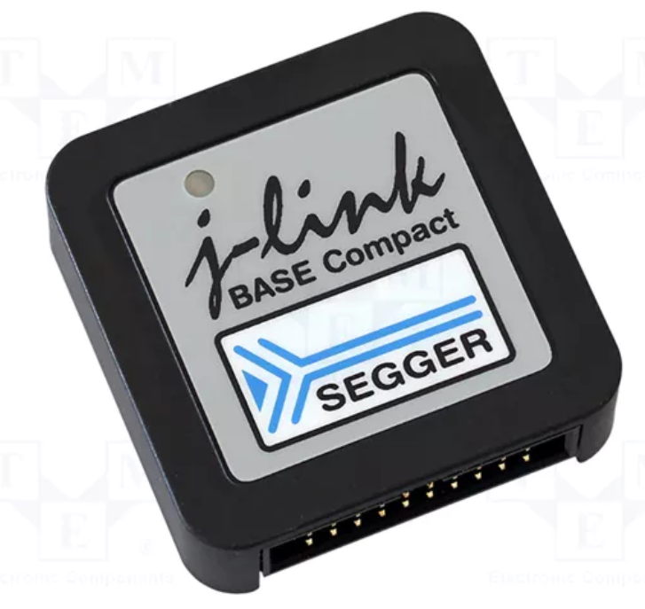

# Boot Modes

Table 3 shows the selection of operating modes by the mode-setting pin(MD pin) and JTAG accessible command.

Table Selection of operating modes by the mode-setting pin

|  |  |  |  |
| --- | --- | --- | --- |
| **Mode-setting pin (MD)** | **Operating mode** | **On-chip Flash** | **External bus** |
| 1 | Single chip mode/  JTAG Boot Mode | Enable | Disable |
| 0 | SCI / USB boot mode | Enable | Disable |

## Single-Chip Mode

In single-chip mode, all I/O pins are available for use as input or output port, inputs or outputs for peripheral functions, or as interrupt inputs. When a reset is released while the MD pin is high, the MCU starts in single-chip mode and the on-chip flash is enabled.

## JTAG Boot Mode

In this mode, the on-chip flash memory programming routine (JTAG boot program), stored in the boot area within the MCU, is used. The on-chip flash, including code flash memory and data flash memory, can be modified from outside the MCU by using the JTAG and SWD interface.

To enter this mode, it is necessary to input the request from the JTAG and SWD-I/F during RES-pin reset.

## SCI Boot Mode

In this mode, the on-chip flash memory programming routine (SCI boot program), stored in a dedicated area within the MCU, is used. The on-chip flash including the code flash memory and data flash memory can be modified from outside the MCU by using a universal asynchronous receiver/transmitter (UART) SCI. The MCU starts in SCI boot mode if the MD pin is held low on release from the reset state.

## USB Boot Mode

In this mode, the on-chip flash memory programming routine (USB boot program), stored in the boot area within the MCU, is used. The on-chip flash, including the code flash memory and data flash memory, can be modified from outside the MCU by using the USB.

# Firmware Flashing

This board supports multiple firmware update methods:

* Via Jlink-OB
* Via SEGGER J-Link

# Legal, Safety & Warranty Notices

This product is intended for development purposes only. Not for life-critical applications.

* Follow all ESD safety procedures
* Avoid hot-plugging interfaces not designed for runtime connection
* Warranty limited to manufacturing defects; see distributor’s terms
* Refer to the latest datasheets and manuals at: [www.renesas.com](http://www.renesas.com)

# Reference Documents

* [e2 studio](https://www.renesas.com/en/software-tool/e-studio?srsltid=AfmBOopkFO_B-Ia1VJs1_12BrgYmEEVMGEqmL7OPDcgIhAas1fmcn6qJ)
* [RA8D1 Flexible Software Package](https://www.renesas.com/en/software-tool/flexible-software-package-fsp)
* [Renesas RA8D1 Page](https://www.renesas.com/en/products/microcontrollers-microprocessors/ra-cortex-m-mcus/ra8d1-480mhz-arm-cortex-m85-based-graphics-microcontroller-helium-and-trustzone?srsltid=AfmBOorHMlDcEbUuMEsF1isnYlES3rb85d9bCyPAVVo092924-1CMB72%23documents)
* [Renesas Flash Programmer (Programing GUI)](https://www.renesas.com/en/software-tool/renesas-flash-programmer-programming-gui)
* [Renesas RA8D1 Group User Manual](https://www.renesas.com/en/document/mah/ra8d1-group-users-manual-hardware?r=25456556)
* [Renesas RA8D1 Group Datasheet](https://www.renesas.com/en/document/dst/ra8d1-group-datasheet?r=25456556)